EXPERIMENT NO:- 2,3,5,7:

Design and configuration of STAR, MESH, BUS and HYBRID topology using packet tracer.

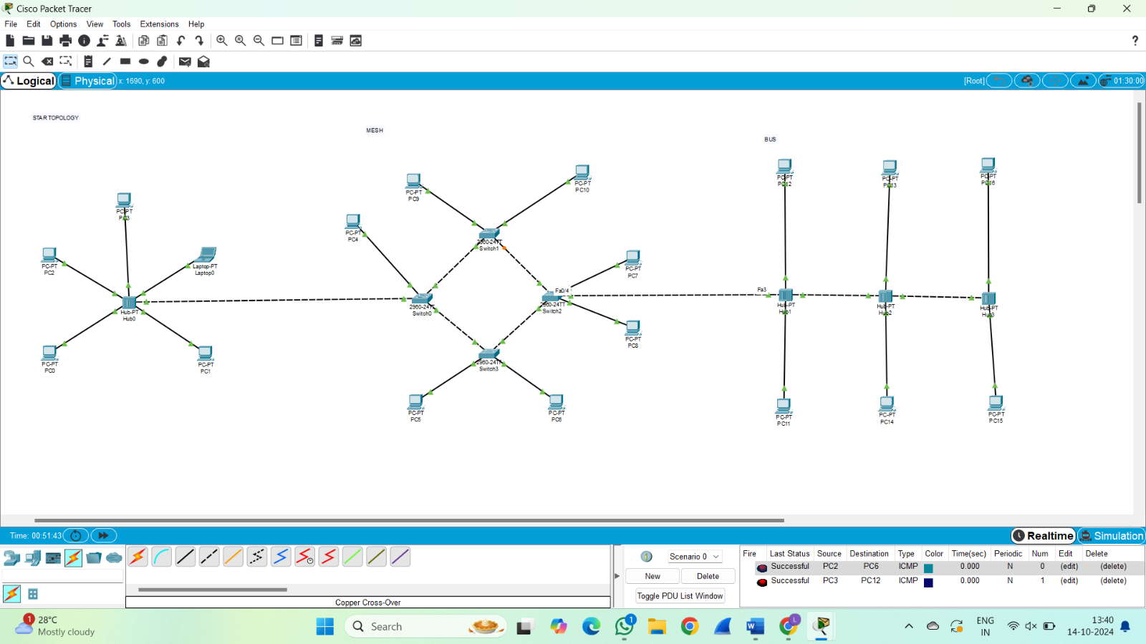

EXPERIMENT NO:- 4:

Design and configuration of RING topology using packet tracer.

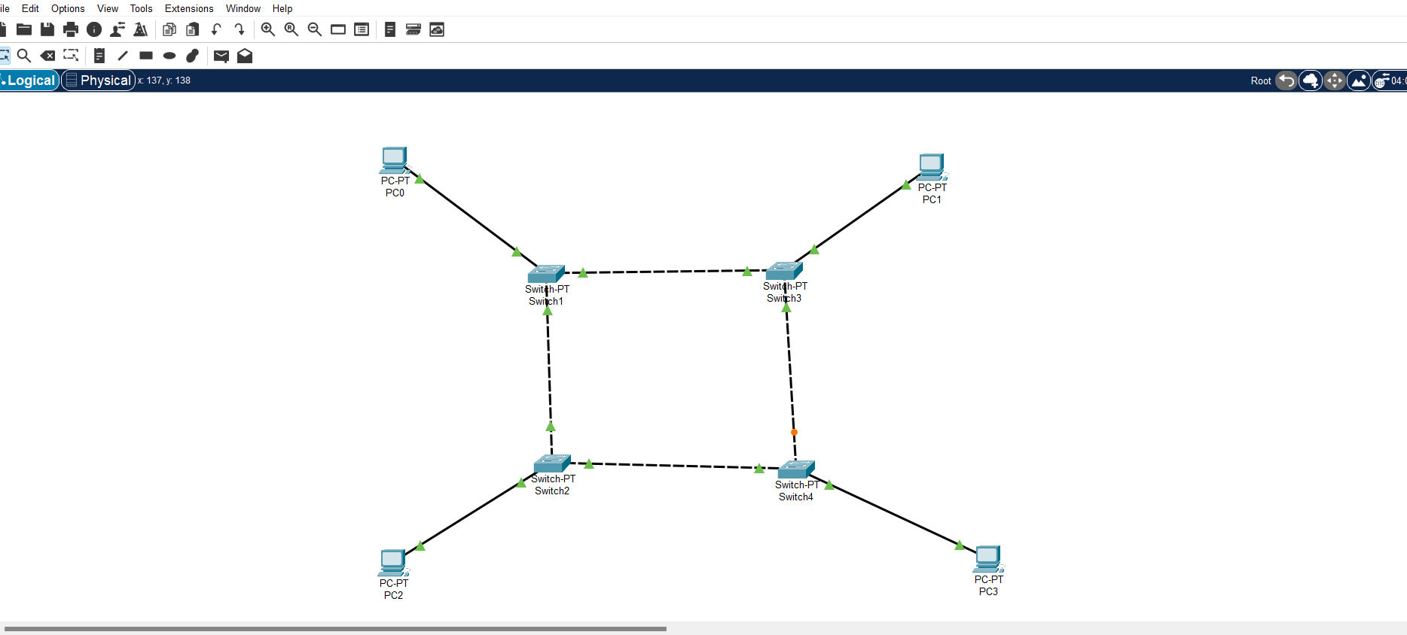

EXPERIMENT NO:- 6:

Design and configuration of TREE topology using packet tracer. 